**Module 1 Activity 1: Installation of Tools (Integrated Development Environment)**

**Submitted By: Devi Subadra Venkatesan**

**IFT 458 & IFT 554: Middleware Programming & Database Security**

**Instructor: Dinesh Sthapit**

**Due Date: 01/21/2024**

**Visual Studio Code (VS Code) Installation:**

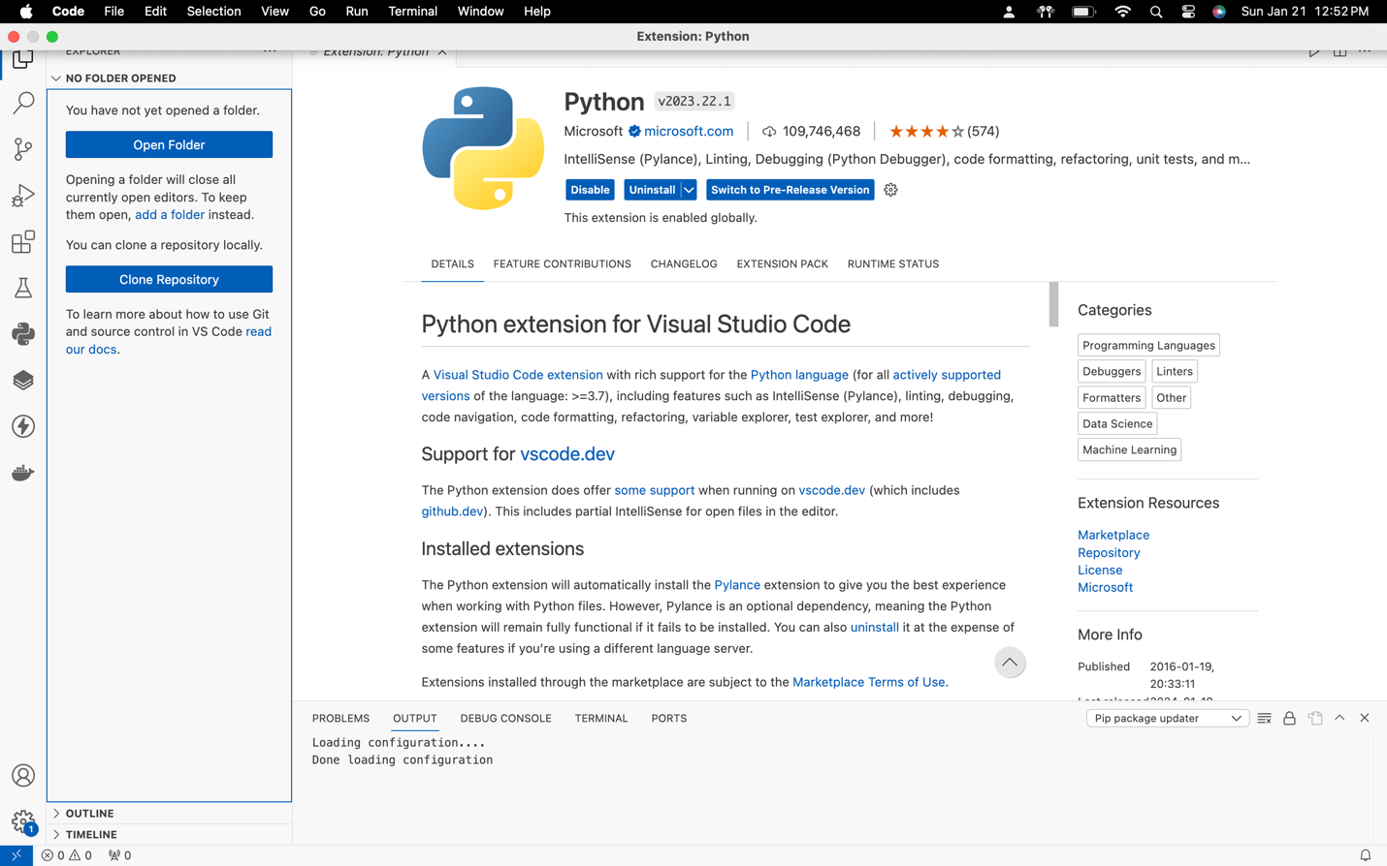

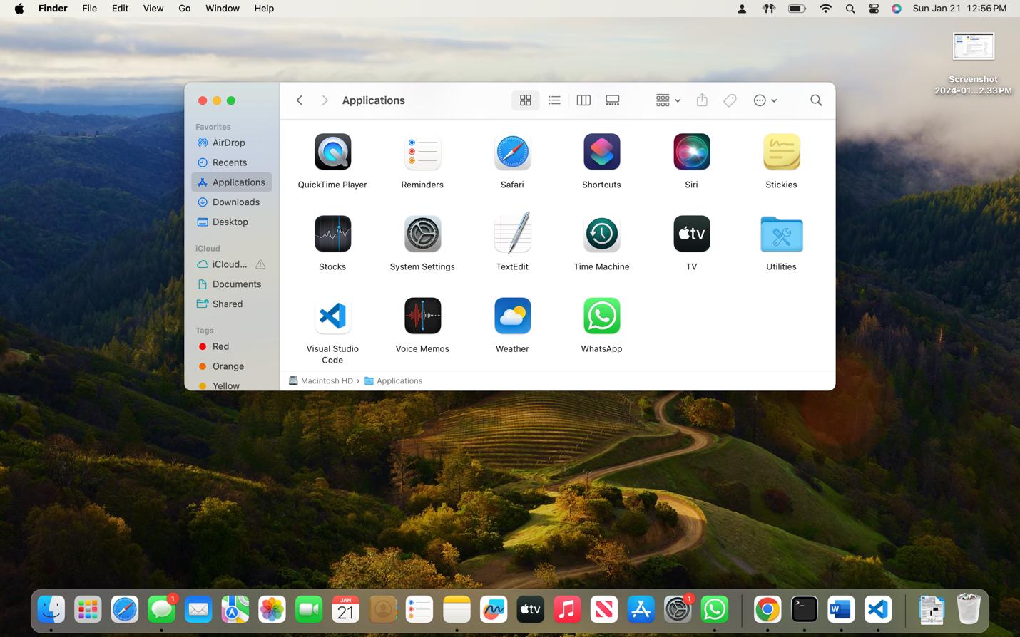

**Node.js Installation:**

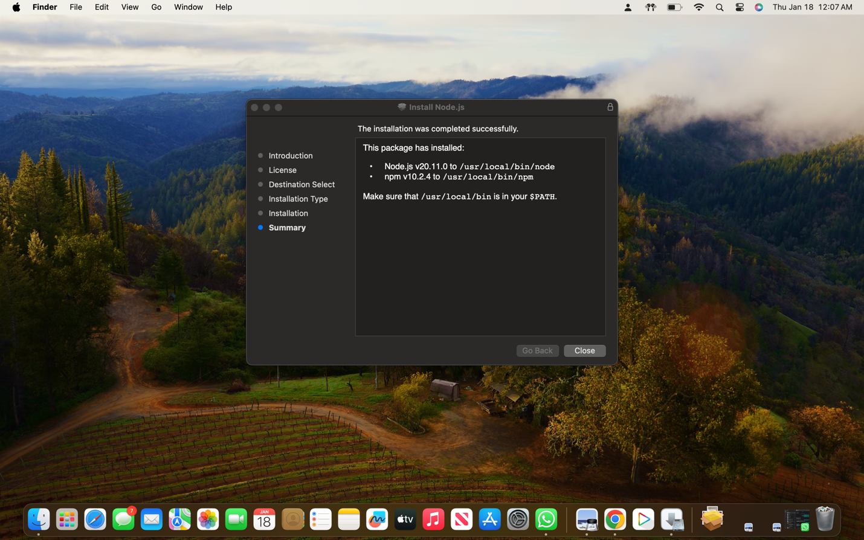

**version output :** node -v

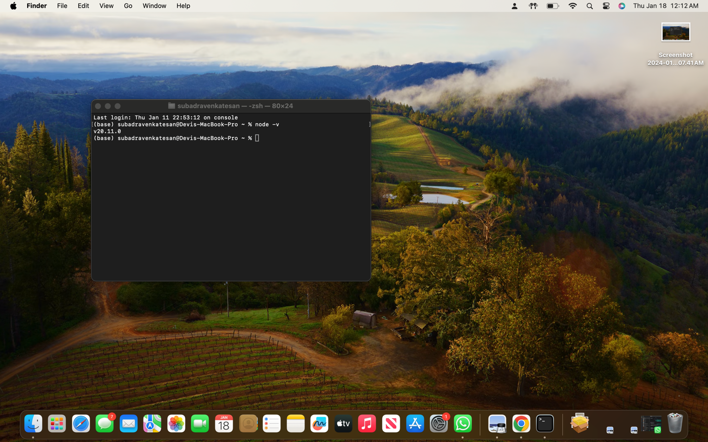

**npm (Node Package Manager) version:** npm -v

